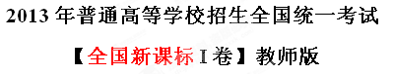
【试卷总评】2013年全国新课标I卷高考试题总体难度适中，没有偏题、怪题。单项填空考查知识全面，题干简洁、明快，容易理解；完形填空考查的是一篇记叙文。文章讲述了作者参加了一次周日残疾体验活动，通过对自己几个小时使用轮椅的详细记叙，说明了残疾人生活的不易。文章的最后给我们这样的启示：残疾人必须要克服心理和身体上的挑战。故事情节清晰，逻辑性强，易于理解；阅读理解总体难度适中，没有过难的文章；阅读文章体裁广泛包括：应用文、记叙文、科技说明文和议论文。但阅读语篇的难度是由难到易，D篇最简单，这可能会对考生在考场上造成压力。7选5很好地考查学生的语境理解和综合概括能力，以及议论文的写作方法。写作是一篇应用文。写信是中学生最熟悉的事，这种形式的写作贴近学生生活，使他们有话可说。总之，2013年全国新课标I卷是一套难度适中的试卷。

第Ⅰ卷
注意事项：
- 答第Ⅰ卷前，考生务必将自己的姓名、考生号填写在答题卡上。
- 选出每小题答案后，用铅笔把答题卡上对应题目的答案标号涂黑。如需改动，用橡皮擦干净后，再选涂其他答案标号。不能答在本试卷上，否则无效。
第一部分 听力（共两节，满分30分）
做题时，先将答案标在试卷上。录音内容结束后，你将有两分钟的时间将在试卷上的答案转涂到答题卡上。
第一节（共5小题；每小题1. 5分，满分7. 5分）
听下面5段对话。每段对话后有一个小题，从题中所给的A、B、C三个选项中选出最佳选项，并标在试卷的相应位置。听完每段对话后，你都有10称钟的时间来回答有关小题如阅读下一小题。每段对话仅读一遍。
例：How much is the shirt?
A. ￡19. 15. B. ￡9.18. C. ￡9.15.
答案是C。

1. What does the man want to do?
A. Take photos. B. Buy a camera. C. Help the woman.
2. What are the speakers talking about?
A. A noisy night B. Their life in town C. A place of living.
3. Where is the man now?
A. On his way. B. In a restaurant. C. At home
4. What will Celia do?
A. Find a player. B. Watch a game. C. Play basketball.
5. What day is it when the conversation takes place?
A. Saturday. B. Sunday. C. Monday.

第二节（共15小题：每小题1. 5分，满分22. 5分）
听下面5段对话或独白。每段对话或独白后有几个小题，从题中所给的A、B、C三个选项中选出最佳选项，并标在试卷的相应位置。听每段对话或独白前，你将有时间阅读各个小题，每小题5秒钟；听完后，每个小题将给出5秒钟的作答时间。每段对话或独白读两遍。
听第6段材料，回答6、7题。
6. What is Sara going to do?
A. Buy John a gift. B. Give John a surprise C. Invite John to France.
7. What does the man think of Sara’s plan?
A. Funny. B. Exciting. C. Strange.

听第7段材料，回答第8、9题。
8. Why does Diana say sorry to peter?
A. She has to give up her travel pan. B. She wants to visit another city.
C. She needs to put off her test.
9. What does Diana want Peter to do?
A. Help her with her study. B. Take a book to her friend.
C. Teach a geography lesson.
听第8段材料，回答第10至12题。
10. Why does the man call the woman?
A. To tell her about her new job. B. To ask about her job program.
C. To plan a meeting with her.
11. Who needs a new flat?
A. Alex. B. Andrea. C. Miranda.
12. Where is the woman now?
A. In Baltimore. B. In New York. C. In Avon.
听第9段材料，回答第13至16题。
13. What does Jan consider most important when he judges a restaurant?
A. Where the restaurant is. B. Whether the prices are low.
C. How well the food is prepared.
14. When did Jan begin to write for a magazine?
A. After he came back to Sweden. B. Before he went to the United States.
C. As soon as he got his first job in 1982.
15. What may Jan do to find a good restaurant?
A. Talk to people in the street. B. Speak to taxi drivers. C. Ask hotel clerks.
16. What do we know about Jan?
A. He cooks for a restaurant. B. He travels a lot of his work.
C. He prefers American food.
听第10段材料，回答第17至20题
17. What do we know about the piaza Leen?
A. it’s new building B. it’s a small town C. it’s public place
18. When do parents and children like going to the Piaza Leen?
A. Saturday nights B. Sunday afternoons C. Fridays and Saturdays.
19. Which street is known for its food shops and markets?
A. Via dei Mar Street B. Femando Street. C. Hemandes Street
20. Why does the speaker like Horation Street best?
A. It has an old stone surface. B. it is named after a writer C. It is a famous university.

第二部分 英语知识运用（共两节，满分45分）
第一节 单项填空（共15小题；每小题1分，满分15分）
从A、B、C、D四个选项中，选出可以填入空白处的最佳选项，并在答题卡上将该项涂黑。
例：We ________ last night, but we went to the concert instead.
A. must have studied B. might study
C. should have studied D. would study
答案是C。
21.—Why, this is nothing but common vegetable soup!
—_________ , madam. It's our soup of the day!
A. Let me see B. So it is C. Don't mention it D. Neither do I
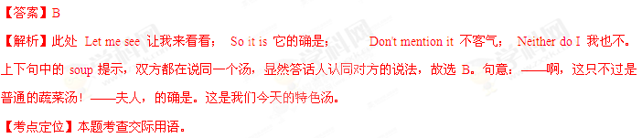22. They might just have a place ________ on the writing course— why don’t you give it a try?
A. leave B. left C. leaving D. to leave
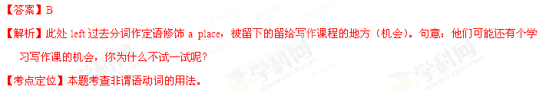23. Try not to cough more than you can _______ since it may cause problems to your lungs.
A. check B. allow C. stop D. help
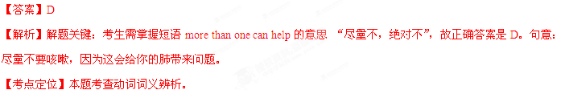24. If we _________ now to protect the environment, we’ll live to regret it.
A. hadn’t acted B. haven’t acted C. don’t act D. won’t act
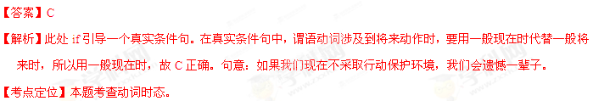25. Tony can hardly boil an egg, still ________ cook dinner.
A. less B. little C. much D. more
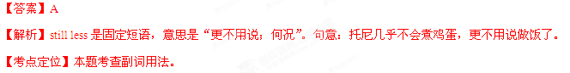
26. Police have found ________ appears to be the lost ancient statue.
A. which B. where C. how D. what
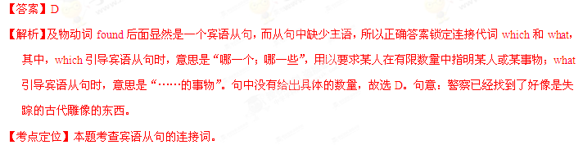27. When I first met Bryan I didn’t like him, but I ________ my mind.
A. have changed B. change C. had changed D. would change
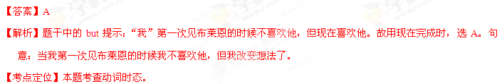28. The drive wanted to park his car near the roadside but was asked by the police ________ .
A. not to do B. not to C. not do D. do not
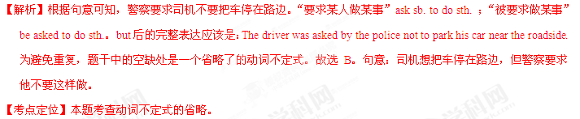29. The door ________ open, no matter how hard she pushed.
A. shouldn’t B. couldn’t C. wouldn’t D. mightn’t
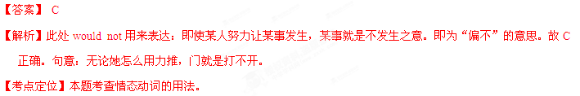30. At the last moment, Tom decided to ________ a new character to make the story seem more likely.
A. put up B. put in C. put on D. put off
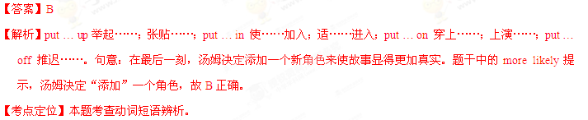31. India attained ________ independence in 1947, after _______ long struggle.
A. 不填; a B. the; a C. an; 不填 D. an; the
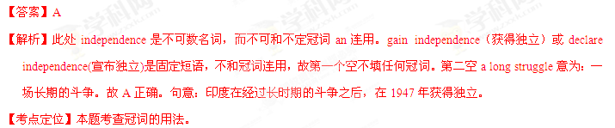32. There’s no way of knowing why one man makes an important discovery ________ another man, also intelligent, fails.
A. since B. if C. as D. while
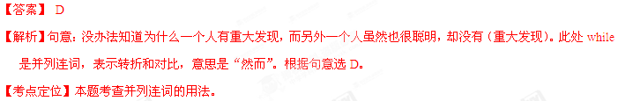33. “You can’t judge a book by its cover,” ________ .
A. as the saying goes old B. goes as the old saying
C. as the old saying goes D. goes as old the saying
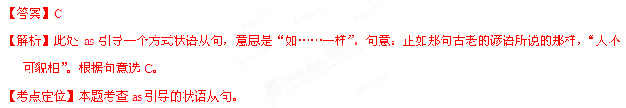34. It was a real race _______ time to get the project done. Luckily, we made it.
A. over B. by C. for D. against
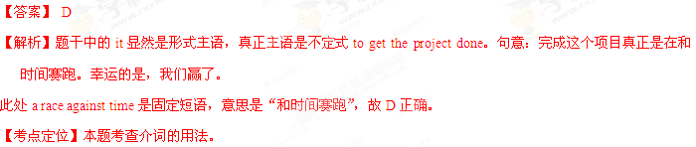35. The sunlight is white and blinding, _______ hard-edged shadows on the ground.
A. throwing B. being thrown C. to throw D. to be thrown
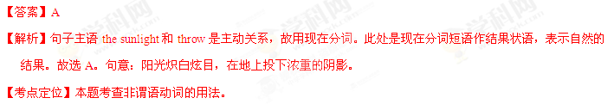第二节 完形填空（共20小题；每小题1.5分，满分30分）
阅读下面短文，从短文后各题所给的四个选项A、B、C和D中，选出可以填入空白处的最佳选项，并在答题卡上将该项涂黑。
I went to a group activity, “Sensitivity Sunday” which was to make us more 36 the problem faced by disabled people. We were asked to “ 37 a disability” for several hours one Sunday. Some member 38 chose the wheel chair. Other wore sound-blocking earplugs (耳塞) or blindfolds (眼罩).
Just sitting in the wheelchair was a 39 experience, I had never considered before how 40 it would be to use one. As soon as I sat down my 41 made the chair begin to roll. Its wheel were not 42 . Then I wondered where to put my 43 , It took me quite a while to get the metal footrest into 44 , I took my first uneasy look at what was to be my only means of 45 for several hours. For disabled people, “adopting a wheelchair” is not a temporary(临时的) 46 .
I tried to find a 47 position and thought it might be restful, 48 kind of nice to be 49 around for a while. Looking around, I 50 would have to handle the thing myself! My hands started to ache as I 51 the heavy wheels, I came to know that controlling the 52 of the wheelchair as not going to be 53 task,
My wheelchair experiment was soon 54 . It made a deep impression on me. A few hours of “disability” gave me only a taste of the 55 , both physical and mental, that disabled people must overcome.
36. A. curious about B. aware of C. interested in D. careful with
37. A. cure B. adopt C. prevent D. analyze
38. A. inserted B. strangely C. as usual D. like me
39. A. learning B. working C. satisfying D. relaxing
40. A. convenient B. awkward C. boring D. exciting
41. A. height B. force C. skill D. weight
42. A. locked B. repaired C. powered D. grasped
43. A. hands B. feet C. keys D. handles
44. A. place B. action C. play D. effect
45. A. operation B. communication C. transportation D. production
46. A. exploration B. education C. experiment D. entertainment
47. A. flexible B. safe C. starting D. comfortable
48. A. yet B. just C. still D. even
49. A. shown B. pushed C. driven D. guided
50. A. realized B. suggested C. agreed D. admitted
51. A. lifted B. turned C. pressed D. seized
52. A. path B. position C. direction D. way
53. A. easy B. heavy C. major D. extra
54. A. forgotten B. repeated C. conducted D. finished
55. A. weaknesses B. anxieties C. challenges D. illnesses
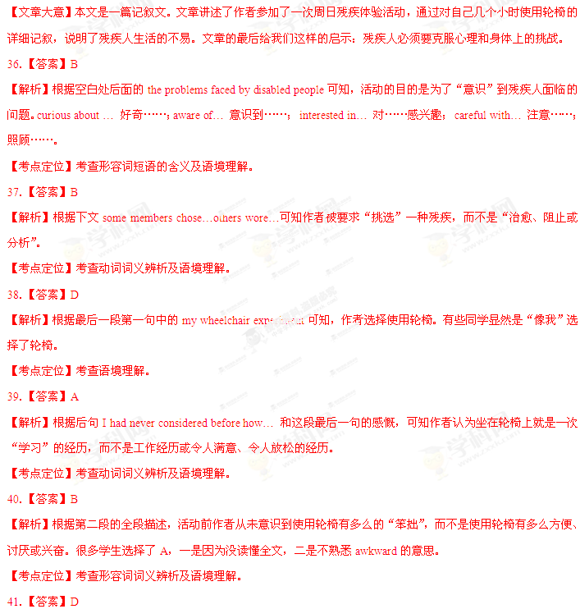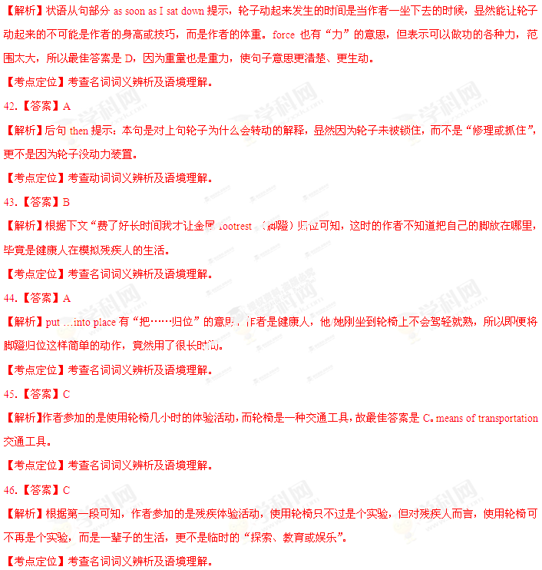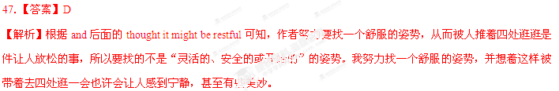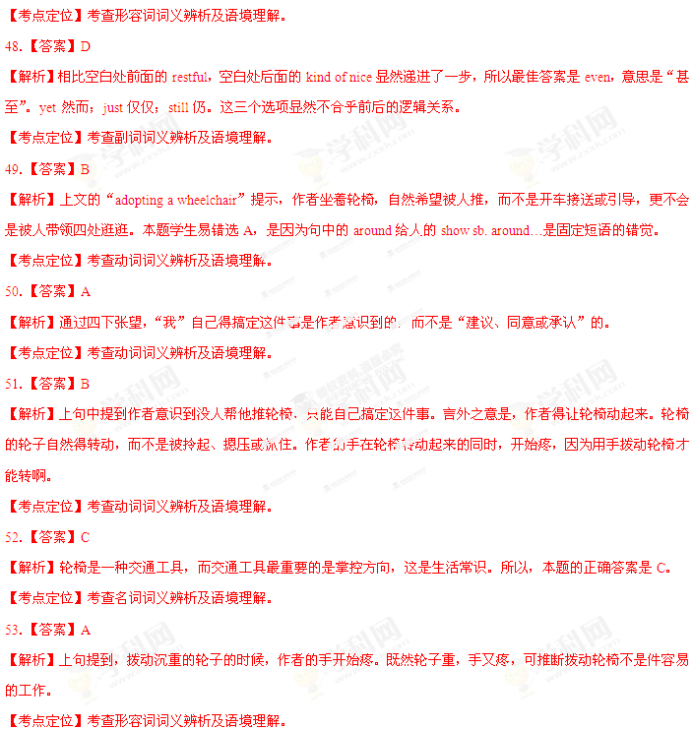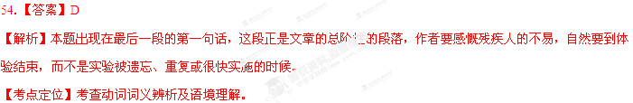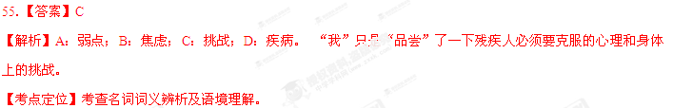第三部分 阅读理解（共两节，满分40分）
第一节（共15小题；每小题2分，满分30分）
阅读下列短文，从每题所给的四个选项（A、B、C和D）中，选出最佳选项，并在答题卡上将该项涂黑。
A
Some people will do just about anything to save money. And I am one of them. Take my family’s last vacation. It was my six-year-old son’s winter break form school, and we were heading home from Fort Lauderdale after a weeklong trip. The flight was overbooked, and Delta, the airline, offered us $400 per person in credits to give up our seats and leave the next day. I had meeting in New York，So I had to get back . But that didn't mean my husband and my son couldn't stay. I took my nine-month-old and took off for home.
The next day my husband and son were offered more credits to take an even later flight. Yes, I encouraged一okay, ordered-them to wait it out at the airport, to "earn" more Delta Dollars. Our total take: $1,600. Not bad, huh?
Now some people may think I'm a bad mother and not such a great wife either. But as a big-time bargain hunter, I know the value of a dollar. And these days, a good deal is something few of us can afford to pass up.
I've made living looking for the best deals and exposing (揭露) the worst tricks . I have been the consumer reporter of NBC's Today show for over a decade. I have written a couple of books including one titled Tricks of the Trade: A Consumer Survival Guide. And I really do what I believe in. I tell you this because there is no shame in getting your money’s worth. I’m also tightfisted when it comes to shoes, clothes for my children, and expensive restaurants. But I wouldn't hesitate to spend on a good haircut. It keeps its longer, and it's the first thing people notice. And I will also spend on a classic piece of furniture. Quality lasts.

56. Why did Delta give the author's family credits?
A. They took a later flight.
B. They had early bookings.
C. Their flight had been delayed.
D. Their flight had been cancelled.
57. What can we learn about the author?
A. She rarely misses a good deal.
B. She seldom makes a compromise.
C. She is very strict with her children
D. She is interested in cheap products.
58. What does the author do?
A. She's a teacher.
B. She's a housewife.
C. She's a media person.
D. She's a businesswoman.
59. What does the author want to tell us?
A. How to expose bad tricks.
B. How to reserve airline seats.
C. How to spend money wisely,
D. How to make a business deal.
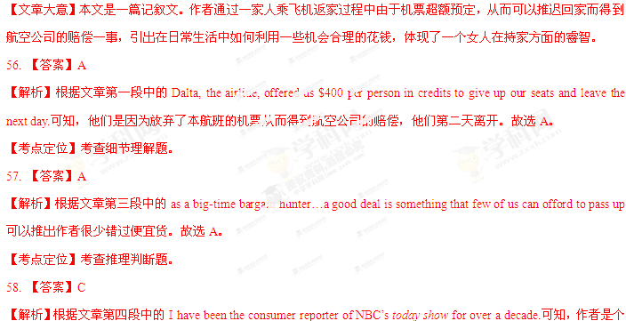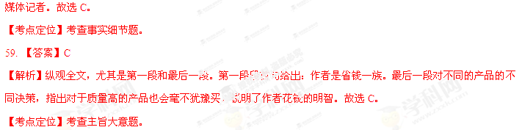
B
The baby is just one day old and has not yet left hospital. She is quiet but alert (警觉). Twenty centimeters from her face researchers have placed a white card with two black spots on it. She stares at it carefully. A researcher removes the card and replaces it by another, this time with the spots differently spaced. As the cards change from one to the other, her gaze(凝视) starts to lose its focus - until a third, with three black spots, is presented. Her gaze returns; she looks at it for twice as long as she did at the previous card. Can she tell that the number two is different from three, just 24 hours after coming into the world?
Or do newborns simply prefer more to fewer? The same experiment, but with three spots shown before two, shows the same return of interest when the number of spots changes. Perhaps it is just the newness? When slightly older babies were shown cards with pictures of objects(a comb, a key, an orange and so on), changing the number of objects had an effect separate from changing the objects themselves. Could it be the pattern that two things make, as opposed to three? No again. Babies paid more attention to squares moving randomly on a screen when their number changed from two to three, or three to two. The effect even crosses between senses. Babies who were repeatedly shown two spots became more excited when they then heard three drumbeats than when they heard just two; likewise(同样地) when the researchers started with drumbeats and moved to spots.
60. The experiment described in Paragraph 1 is related to the baby’s ______.
A. sense of hearing.
B. sense of sight.
C. sense of touch.
D. sense of smell.
61. Babies are sensitive to the change in ______.
A. the size of cards.
B. the colour of pictures.
C. the shape of patterns.
D. the number of objects.
62. Why did the researchers test the babies with drumbeats?
A. To reduce the difficulty of the experiment.
B. To see how babies recognize sounds.
C. To carry their experiment further.
D. To keep the babies’ interest.
63. Where does this text probably come from?
A. Science fiction.
B. Children’s literature.
C. An advertisement.
D. A science report.
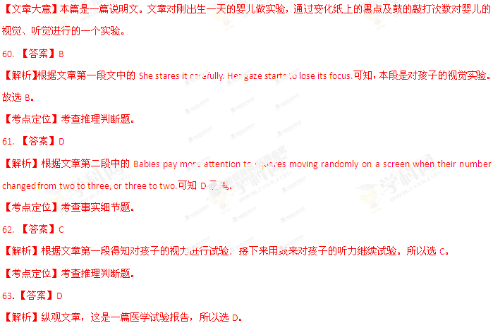
C
It happened to me recently. I was telling someone how much I had enjoyed reading Barack Obama’s Dreams From My Father and how it had changed my views of our President. A friend I was talking to agreed with me that it was ,in his words, “a brilliantly（精彩地）written book”. However, he then went on to talk about Mr Obama in a way which suggested he had no idea of his background at all. I sensed that I was talking to a book liar.
And it seems that my friend is not the only one. Approximately two thirds of people have lied about reading a book which they haven’t. In the World Book Day’s “Report on Guilty Secrets”, Dreams From My Father is at number 9. The report lists ten books, and various authors, which people have lied about reading, and as I’m not one to lie too often (I’d hate to be caught out ),I’ll admit here and now that I haven’t read the entire top ten . But I am pleased to say that, unlike 42 percent of people, I have read the book at number one, George Orwell’s 1984. I think it’s really brilliant.
The World Book Day report also has some other interesting information in it. It says that many people lie about having read Jane Austen, Charles Dickens, Fyodor Dostoevsky(I haven’t read him, but haven’t lied about it either )and Herman Melville.
Asked why they lied, the most common reason was to “impress” someone they were speaking to. This could be tricky if the conversation became more in –depth!
But when asked which authors they actually enjoy, people named J. k. Rowling, John Grisham, Sophie Kinsella (ah, the big sellers, in other words). Forty-two percent of people asked admitted they turned to the back of the book to read the end before finishing the story(I’ll come clean: I do this and am astonished that 58 percent said they had never done so).

64. How did the author find his friend a book liar?
A. By judging his manner of speaking.
B. By looking into his background.
C. By mentioning a famous name.
D. By discussing the book itself.
65. Which of the following is a “guilty secret” according to the World Book Day report?
A. Charles Dickens is very low on the top-ten list.
B. 42% of people pretended to have read 1984.
C. The author admitted having read 9 books.
D. Dreams From My Father is hardly read.
66. By lying about reading, a person hopes to .
A. control the conversation
B. appear knowledgeable
C. learn about the book
D. make more friends
67. What is the author’s attitude to 58%of readers?
A. Favorable.
B. Uncaring
C. Doubtful
D. Friendly
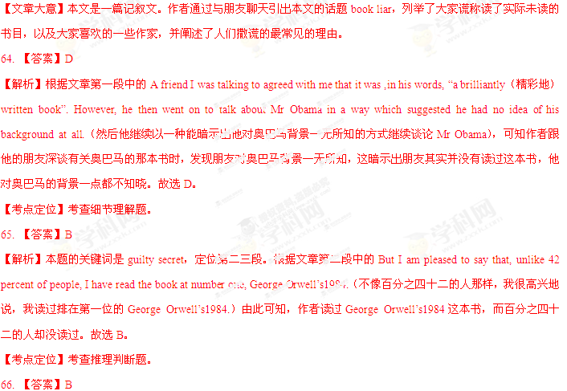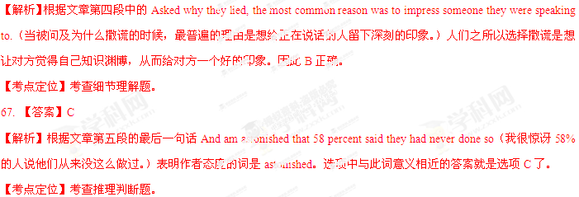D
The National Gallery
Description:
The National Gallery is the British national art museum built on the north side of European art ranging from 13th-century religious paintings to more modern ones by Renoir and Van Gogh. The older collections of the gallery are reached through the main entrance while the more modern works in the East Wing are most easily reached from Trafalgar Square by a ground floor entrance
Layout:
The modern Sainsbury Wing on the western side of the building houses 13th-to15th-century paintings, and artists include Duccio, Uccello, Van Eyck, Lippi, Mantegna, Botticelli and Memling.
The main West Wing houses 16th-century paintings, and artists include Leonardo da Vinci, Cranach, Michelangelo, Raphael, Bruegel, Bronzino, Titan and Veronest.
The North Wing houses 17th-century paintings, and artists include Caravaggio, Rubens, Poussin, Van Dyck, Velazquez, Claude and Vermeer.
The East Wing houses 18th-to early 20th-century paintings, and artists include Canaletto, Goya, Turner, Constable, Renoir and Van Gogh
Opening Hours:
The Gallery is open every day from 10am to 6pm (Fridays 10anm to 9pm) and is free, but charges apply to some special exhibitions.
Getting There:
Nearest underground stations: Charing Cross (2-minute walk). Leicester Square (3-minute walk), Embankment (7-minute walk), and Piccadilly Circus(8-minute walk).

68. In which century’s collection can you see religious paintings?
A. The 13th
B. The 17th
C. The 18th
D. The 20th
69. Where are Leonardo da Vinci’s works shown?
A. In the East Wing.
B. In the main West Wing.
C. In the Sainsbury Wing.
D. In the North Wing.
70. Which underground station is closest to the National Gallery?
A. Piccadilly Circus.
B. Leicester Square.
C. Embankment.
D. Charing Cross.
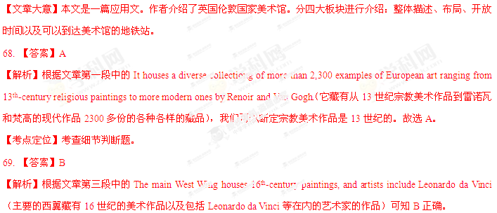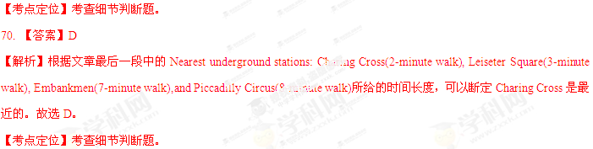第二节(共5小题:每小题2分，满分10分)
根据短文内容，从短文后的选项中选出能填入空白处的最佳选项。
选项中有两项为多余选项。
Business is the organized approach to providing customers with the goods and services they want. The word business also refers to an organization that provides these goods and services. Most business seek to make a profit(利润) - that aim to achieve income that is more than the costs of operating the business. 71 Commonly called nonprofits, these organizations are primarily nongovernmental service providers. 72 .
Business management is a term used to describe the techniques of planning, direction, and control of the operations of a business. 73 One is the establishment (制定)of broad basic policies with respect to production; sales; the purchase of equipment, materials and supplies; and accounting. 74 The third relates to the establishment of standards of word in all departments. Direction is concerned primarily with supervision(监管)and guidance by the management in authority. 75
A. Control includes the use of records and reports to compare actual work with the set standards for work.
B. In this connection there is the difference between top management and operative management.
C. Examples of nonprofit business include such organizations as social service agencies and many hospitals.
D. However, some businesses only seek to enough to cover their operating costs
E. The second aspect relates to the application of these policies by departments.
F. In the theory of business management, organization has two main aspects.
G Planning in business management has three main aspects.
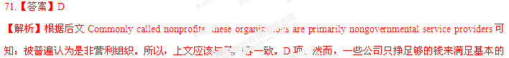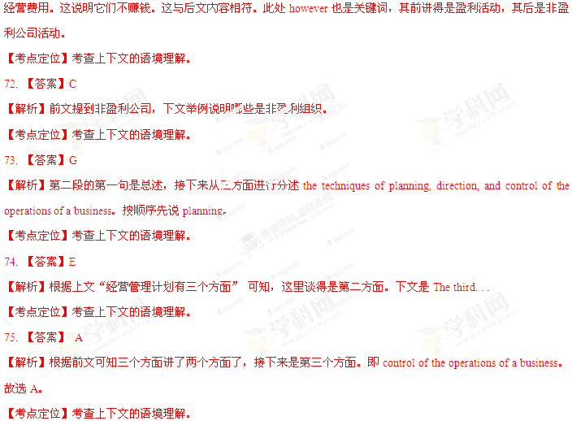
第四部分 写作（共两页，满分35分）
第一节[2013·新课标I] 短文改错（共10小题；每小题1分，满分10分）
假定英语课上老师要求同桌中间交换修改作文，请你修改你同桌写的以下作文。文中共有10处语言错误，每句中最多有两处，每处错误仅涉及一个单词的增加、删除或修改。
增加：把缺词处叫个娄子符号（∧），并在其下面写出该加的词。
删除： 把多余的词用斜线（\）划掉。
修改：在错的词下划一横线，并在该词下面写出修改后的词。

注意：1. 每处错误及其修改均仅限一词；
2. 只允许修改10处，多者（从第11处起）不计分。
I hardly remember my grandmother. She used to holding me on her knees and sing

old songs. I was only four when she passes away. She is just a distant memory for me

now.
I remember my grandfather very much. He was tall, with broad shoulder and a beard

that turned from black toward gray over the years. He had a deep voice, which set himself

apart from others in our small town, he was strong and powerful. In a fact, he even

scared my classmates away during they came over to play or do homework with me.

However, he was the gentlest man I have never known.

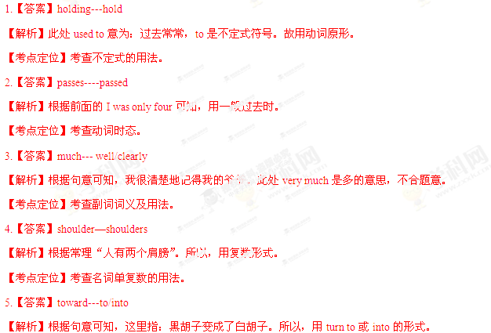
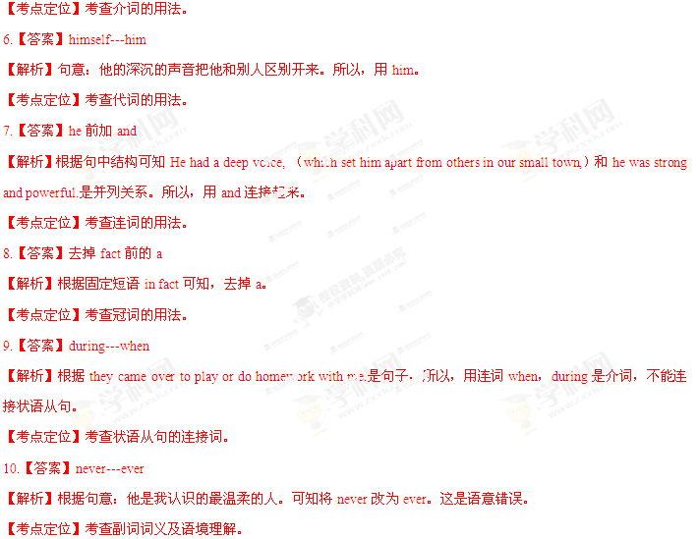第二节 书面表达(满分25分)
假定你是李华。请你给笔友Peter写封信，告诉他你叔叔李明将去他所在城市开会，带去他想要的那幅中国画，同时询问他是否可以接机。信中还需说明：
李明：高个子，戴眼镜
航班号：CA985
到达：8月6日上午11:30
注意：1. 词数100左右
2. 可以适当增加细节，以使行文连贯；
3. 开头语和介绍语已为你写好。
Dear Peter,
How are you doing?___________________________________________________
__________________________________________________________________________________________________________________________________________________
Looking forward to your reply.
Yours,
Li Hua

